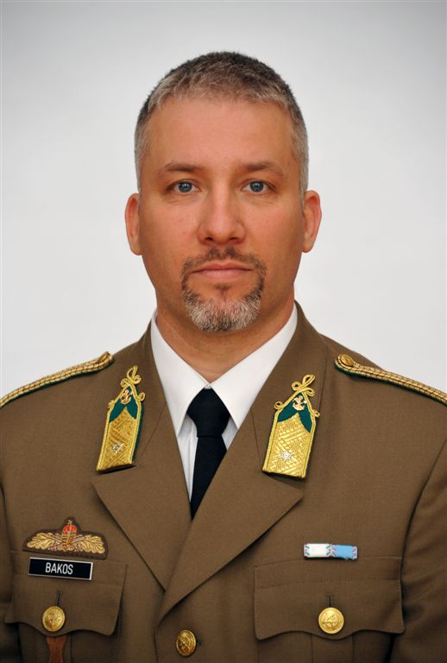
Bakos Tamás
Address: 2017 Pócsmegyer, Galagonya 10.
Email: bakos.tamas@hm.gov.hu
bakos.tamas@uni-nke.hu
Phone: +36 (1) 432-9000 / 229-528
Place and Date of Birth: Miskolc, 1975.06.10.
Nationality: Hungarian

PROFESSIONAL EXPERIENCE
1997-1999 | HDF 37th Ferenc Rákóczi II Engineer Brigade, Szentes  Reconnaissance Squadron,  Section Commander, Squadron Commander (1999)
1999-2001 | HDF NCO Training School and College, Szentendre  1th Vocational training group  instructor chief officer - military engineering
2001-2009 | HDF Kinizsi Pál NCO Training School, Szentendre  Vocational training group 1  instructor officer - military engineering
2009-2010 | HDF Operation Centre, Budapest  Drafting department  officer
2011-2014 | HDF Operations and Doctrine Centre, Budapest  Policy development department  senior officer
2014-2016 | HDF Training and Doctrine Centre, Budapest  Training and Training Control Department  senior officer - military engineering
2016-2017 | Hungarian Defense Forces Formation, Preparation and Training Command, Budapest  Training and Training control department  senior officer - military engineering
2017- | University of Public Service Faculty of Military Science and Officer Training, Budapest  Department of Operations and Support  instructor - military engineering

EDUCATION
1993-1997 | Military College Kossuth Lajos  Engineer officer, Civil engineer (BsC)
2006-2008 | Budapest University of Technology and Economics  Engineer teacher (BsC)
2007-2009 | Zrínyi Miklós University of National Defense  Disaster management engineer (MsC)
2016- | University of Public Service  Doctoral School of Military Engineering  Research field: Military Engineering Infrastructures

MEDALS, AWARDS
1998. 12. 14. | Prize for flood-control
2003. 08. 20. | 3th degree Service medal for military officers
2006. 05. 20. | Service medal for flood-control
2010. 05. 21. | Service Merit Award Bronze degree
2012. 05. 21. | Soldier of the Year 2012
2013. 08. 20. | 2th degree Service medal for military officers
2016. 03. 21. | Service medal for crisis management
2019. 10. 22. | Prize for teaching work

OTHER ACADEMIC AND PROFESSIONAL ACTIVITIES
1996 | Parachute course
1999 | CMAS (**) scuba diver
2002 | Pyrotechnics course
2002 | Fire protection course
2004-2005 | Distance learning developer
2005 | Distance learning tutor
2012 | ECDL course
2014 | TÜV Rheinland InterCert qualified instructor for explosion protection
2018 - | Hungarian Association of Military Science, Engineer section  secretary

LANGUAGE SKILLS
English | intermediate level
French | basic level - ARMA

